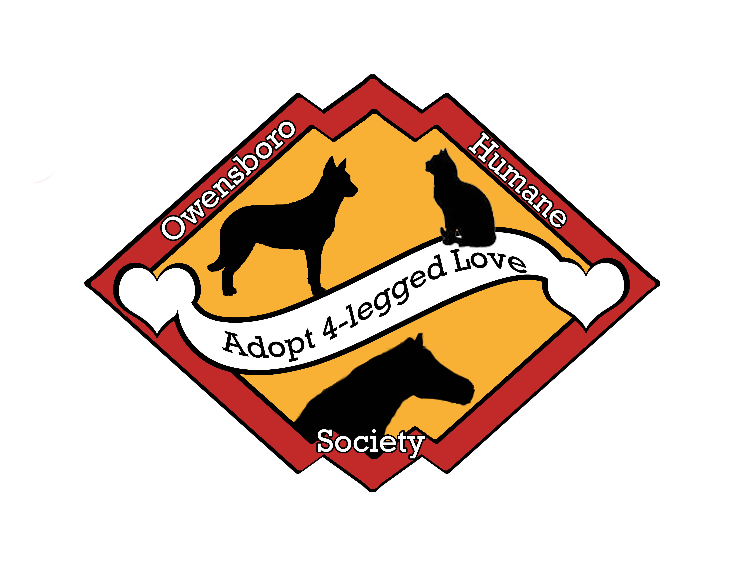

OWENSBORO HUMANE SOCIETY

OHS Volunteer Application 18 yrs+
Thank you for your interest in volunteering with the homeless animals at the Owensboro Humane Society. Volunteers are the backbone to keeping Daviess County’s homeless animals healthy and happy. Whether you want to help better the lives of the homeless animals, or you want to prevent abuse by raising awareness of the tragedies that occur when people stop caring for animals, your efforts really make a difference!
Volunteers are asked to work a minimum of twice a month. Volunteer hours are 9:30 am to 4:30 pm seven days a week and special events. We also require a proof of Tetanus shot as well.
Please fill out this application and either email, mail, or drop off the application to the facility. Please send this application to:
Owensboro Humane Society
3101 Second Street
Owensboro, KY 42301
Phone Number: 270-302-6813

Date: __/___/____
PERSONAL INFORMATION
Name:
Address
City, State Zip Code:
Home Phone:
Work Phone:
Cell Phone:
Social Security #:
E-Mail Address:
Have you been convicted of a misdemeanor or felony? If so please explain
Employer or if a student list school and grade:
May we contact you at work?
Do you have a valid Driver’s License?
Drivers License #
Do you have any Pets? What kind?
Are your pets spay/neutered? | (please check)  Yes  No
Are you afraid of any type of animal? If so what kind?

VOLUNTEERING
Why do you wish to volunteer at OHS?
Have you ever volunteered at any other organization? If so what did you do?
Do you have any special skills, interests, or hobbies (photography, graphic design, carpentry, landscaping, etc.) |  Photography  Carpentry   Graphic Design  Landscaping   Other ___________________________
What hours or days would you like to volunteer?
Do you have any laminations (heavy lifting, limited walking, allergies, etc.)? |  Heavy Lifting  Limited Walking   Allergies   Other ___________________________
Are you volunteering to fulfill a school required community service commitment? If so please list the number of hours needed.
How did you hear about our volunteer program:
Please check off any areas you are interested in helping with
___Special Event Volunteers assist with local festivals, trade shows, radio and TV spots and more. Positions are flexible and vary with events. Work alongside our events coordinator at fundraising and shelter events.
___Publicity Volunteers assist with sending out assorted mailings and helps with Flyer/poster distribution for our upcoming events.
___Administration Volunteers assist with answering phone/making calls, sending thank you notes, member notification, and computer data entry
___Ground Volunteers assist with grounds upkeep and shelter projects so that our animals thrive during their stay.
___Animal Care Volunteers play a vital role providing support to our operations department by assisting with facility cleaning and some animal handling duties. These volunteers help with the day to day care of our shelter guests which includes cleaning, handling animals, walking dogs, and assisting the staff.
___Newsletter/Website Volunteers assist with keeping our website, facebook, blogs up to date. They also help us by writing articles for our newsletter.
____Donation Canisters/Food Barrels Volunteers assist with collecting donations throughout the community and sorting then into bins at the humane society.
___Grant Research and Application Volunteers will work with staff members and the board of directors to apply for various grants. A background in grant writing is required.
EMERGENCY NOTIFICATION:
(person to call in case of emergency)
Name:
Address:
City, State, and Zip Code:
Home Phone:
Work Phone:
Your Relationship to this person:

Name: ___________________
MEDICAL
Is there any physical or mental reason that might hinder you from participating in this program? Explain: _____________________________________________________________________________________
_____________________________________________________________________________________
I, further hereby acknowledge that as a volunteer, I may be not eligible for Worker’s Compensation and agree to hold the Owensboro\ Humane Society the same
REFERENCES (2)
Emergency Notification: (person to call in case of emergency)
Name:
Address:
City, State, and Zip Code:
Home Phone:
Work Phone:
Name:
Address:
City, State, and Zip Code:
Home Phone:
Work Phone:

ADITIONAL INFORMATION:
Occasionally the application form makes it difficult for an individual to adequately summarize his/her background. Use the space below and/or back of this form to provide additional information you feel is necessary to describe your full qualifications. Your personal interests; such as hobbies, civic involvement, etc., If more space is needed, please attach additional sheets.
Name: ___________________
CERTIFICATION:
I certify that the above information if correct and complete to the best of my knowledge and belief. I understand that misrepresentation, falsification, or omission of material facet may be cause for rejection of my application or for my termination after selection into the Volunteer Program at the Owensboro Humane Society. I understand and agree that statements made in this application may be subject to verification concerning same and I hereby release any such person from any and all liability for any damage whatsoever incurred in furnishing such information.
____________________________________________________________________________
Applicant Signature Date
____________________________________________________________________________
Owensboro Humane Society Representative/Witness Date
Initial each blank
_____ I agree to conduct myself in a courteous and professional manner as a volunteer and as a representative
of the Owensboro Humane Society.
_____ I agree to abide by all Owensboro Humane Society policies and procedures. I also understand I can I may be
released as a volunteer at any time, for any cause, or for no cause, or no reason at all.
_____ I authorize the Owensboro Humane Society to contact the emergency contact on this application and seek
emergency medical care in case of accident, injury, or illness.
_____ I agree that my services are provided on a volunteer basis without pay or compensation of any kind and all
services are to be performed at my own risk.
_____ I have received a Tetanus vaccination in the last 10 years. I have provided proof of this medical record via
a copy to the volunteer coordinator. I understand I cannot participate in any direct animal care until I
provide this paperwork.
_____ I understand that before I can begin to volunteer I must attend an orientation.
_____ I understand that in handling animals and performing other volunteer’s task there does exist a risk of injury
including physical harm caused by the animals.
_____ I hereby allow the OHS to use any photographs taken of me on property or at a special event for public
relation purposes.

_____ I understand that any request for paperwork to be signed in recognition of volunteer services must be
submitted to the Volunteer Coordinator at least one week in advance of date that signature is needed. I
also understand that any request for a letter of recommendation must be submitted to the Volunteer
Coordinator must be submitted at least two weeks in advance of date letter is needed.
Name: ___________________
I, herby acknowledge that, if I am selected as part of the Owensboro Humane Society Volunteer Program, I serve at the will and please of the Humane Society, it’s supervisors and/or officers, and that I may be released as a volunteer at any time, for any cause, or for no cause, or no reason at all. I agree to abide by the regulations and supervision of the Owensboro Humane Society. I also understand and agree that regardless of any oral or written representations made by the Humane Society, it’s supervisors or officers, my participation as a volunteer will continue to be at the will and please of the Owensboro Humane Society, and it’s officers and staff.
I also understand that no ordinance, resolution, code, order, minutes, rules, regulations, or any other document shall be construed by me as an expressed or implied, contract modifying in any way, serving as a volunteer at will, unless such documents expressly states that it is intended as a volunteer contract and that it is intended to expressly change or modify my individual participation as a volunteer with the Owensboro Humane Society facility.
____________________________________________________________________________
Applicant Signature Date

RELEASE OF LIABILITY
I, the undersigned, in exchange for my being permitted to work as a Owensboro Humane Society volunteer, hereby agree to release the Owensboro Humane Society and hold it harmless for any and all liability for any injury or damage I may receive while volunteering as a Owensboro Humane Society volunteer.

____________________________________________________________________________
Applicant Signature Date
____________________________________________________________________________
Owensboro Humane Society Representative/Witness Date

OHS USE ONLY
Tetanus paperwork Received:
Date Attended Orientation:

